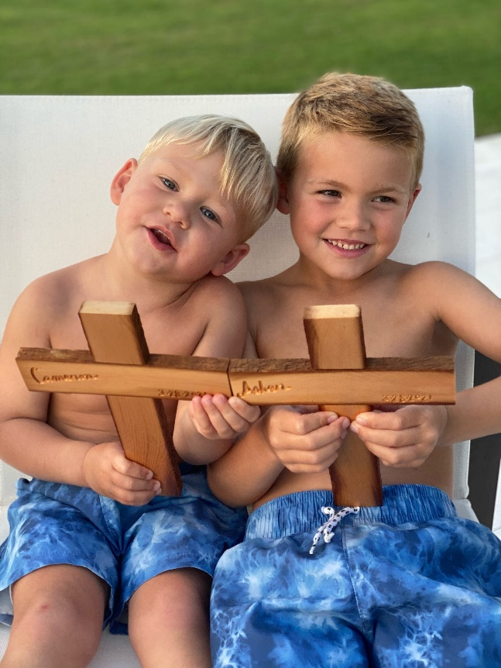GROW…so that we may no longer be children, tossed to and fro by the waves and carried about by every wind of doctrine, by human cunning, by craftiness in deceitful schemes. Rather, speaking the truth in love, we are to grow up in every way into him who is the head, into Christ, from whom the whole body, joined and held together by every joint with which it is equipped, when each part is working properly, makes the body grow so that it builds itself up in love.” – Ephesians 4:14-16

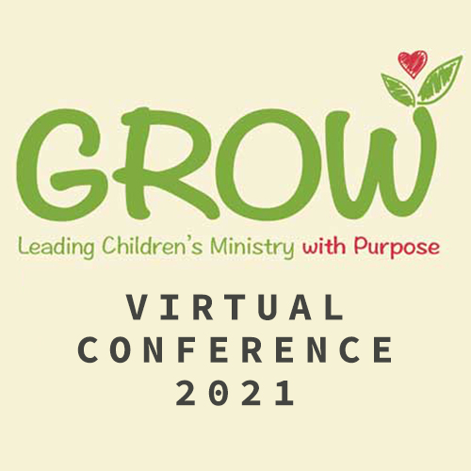
Designed to Equip
Leaders, Teachers and Parents

Covenant Church of Naples
Fellowship Hall

Friday, August 20
6:00 – 9 p.m.

Saturday, August 21
8:30 a.m. to noon

IT’S GROWING Time
This fall the kids are back and we are ready to do all we can do to welcome, love, and encourage them to GROW as they follow Jesus.
Teachers, helpers, parents, leaders, and volunteers join us as we grow in our skills to disciple our children in God’s word!
This multi purpose, multi media training conference will jump-start on August 20-21, 2021, but we will be using components of it throughout the year to continue our training in children’s ministry!
We also promise a great time of fellowship with delicious food and fun with door prizes and give aways as we learn together!
Schedule
Friday
6:00 p.m. Dinner from Carrabbas
7:00 p.m.
Let’s Grow Together
Sherry Kendrick, Family Ministry Director

7:30 p.m.
Growing: Together IN Church
Rev. Scott Barber, Pastor Redeemer Church Florence, Alabama

Saturday
8:30 a.m. Continental Breakfast
9:00 a.m.
Growing: Children and Student Building

10:00 a.m.
Growing: Teaching the Word
Sue Jakes, Children’s Ministry Director, PCA

11:00 a.m.
Growing: The Hearts of the Fathers
Rev. Stephen Estock, Coordinator CDM

